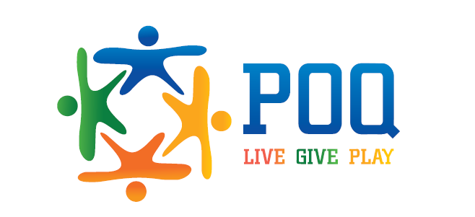
2016 Pride of Quakertown
6th Annual Spring Fling Sponsorship Opportunities
Benefits of Spring Fling Sponsorship | Back-drop  $750 | Cups  $500 | Candy Bar  $300 | Drink  $200 | Drink  $200 | Table  $100
Special recognition on events webpage, name & logo on all printed event material
Sponsorship certificate to display in place of business
Sponsor logo placed on signage around sponsorship location
Sponsor logo on 8’x8’ photo backdrop
One color sponsor logo on 300 reusable plastic 16oz cups
Sponsor logo label on 200 candy bar bags

Sponsorship opportunities for this event may be subject to change. The value of your sponsorship will remain as stated or may be raised to a higher single event sponsorship as needed. Other sponsorship opportunities may be considered, please contact Spring Fling committee to discuss further options.
_ _ _ _ _ _ _ _ _ _ _ _ _ _ _ _ _ _ _ _ _ _ _ _ _ _ _ _ _ _ _ _ _ _ _ _ _ _ _ _ _ _ _ _ _ _ _ _ _ _ _ _ _ _ _ _ _ _ _ _ _ _ _ _ _ _ _ _ _ _ _ _ _ _ _ _ _ _ _ _ _ _ _ _ _ _ _ _ _ _ _ _ _
POQ 2016 Spring Fling Sponsorship Registration Form
Company Name: _______________________________________________________________
Contact Name: ________________________________________________________________
Contact Email: _________________________________________________________________
Contact Phone: ________________________________________________________________
Contact Address: _______________________________________________________________
Sponsorship Level

- Photo Backdrop Sponsor ($750)
- Cup Sponsor ($500)

Please make checks payable to Pride of Quakertown and sent with registration form to PO Box 437, Quakertown, PA 18951.
Email corporate logo to growingtwoflowers@hotmail.com
Any questions please feel free to contact Alexis Murphy (267-221-4858)

- Candy Bar Sponsor ($300)
- Drink Sponsor ($200)

- Drink Sponsor ($200)
- Table Sponsor ($100/ea)

